**Kitchen 5V Addressable LEDs**

**Kitchen Cabinet Upper & Lower:**

Total length of LED strips ordered 16.4 x 2 = 32.8 ft

Total length of cabinet = 34.8 ft

**Materials:**

* 16 AWG, 6 ft, 13A Power Cord
* 5V 60A Transformer Switching Driver Power Supply
* ESP8266 Wi-Fi Module
* BTF LED Strips 60/m IP30
* BTF LED corner connectors
* Aluminum Channel 12mm
* 18 AWG Silicone Stranded Wire (Multicolored)
* Helping Hands Soldering Tool
* Flux Paste
* Soldering Iron Holder w/Brass Coil Cleaner

**Step 1 -** Install Power cord to 5V60A power supply:

**Step 2** - Cut the LED wires:

**Step 3** - Strip all (3) LED Wires

**Step 4** – ESP8266 Wi-Fi Board (3) wires

* Pair Red to Red – Twist together that’s going to the VIN pin on the module to the red voltage wire connected to the LED lights

* Pair Black to White – Twist together, black wire is coming from Wi-Fi module to the GND white wire on the LED lights

* Pair Green to Green – Data wires

**Step 5** – Terminate wires to the 5V 60A power supply (Unplugged Power Supply).

Positive Terminal +V:

* Terminate the red wires in the 1st slot.

Negative Terminal -V:

* Terminate the black and white wires in the 4th slot.

**Step 6** – Download Software from GitHub (macOS Version)

* Flasher Software - [Flasher App](https://github.com/Futrawei/WLED/tree/main/Software%20-%20MacOS/Flasher%20Software/ESPHome-Flasher.app/Contents/MacOS) (Load the flash drive first)
* WLED Software - [WLED Software](https://github.com/Futrawei/WLED/tree/main/Software%20-%20MacOS/WLED%20Software) (Download the latest software version)

**Step 7** – Run Software

* Run the flasher software

* Plug in the ESP8266 Wi-Fi Module to computer with a USB cable

* Run the 2nd software which is the firmware

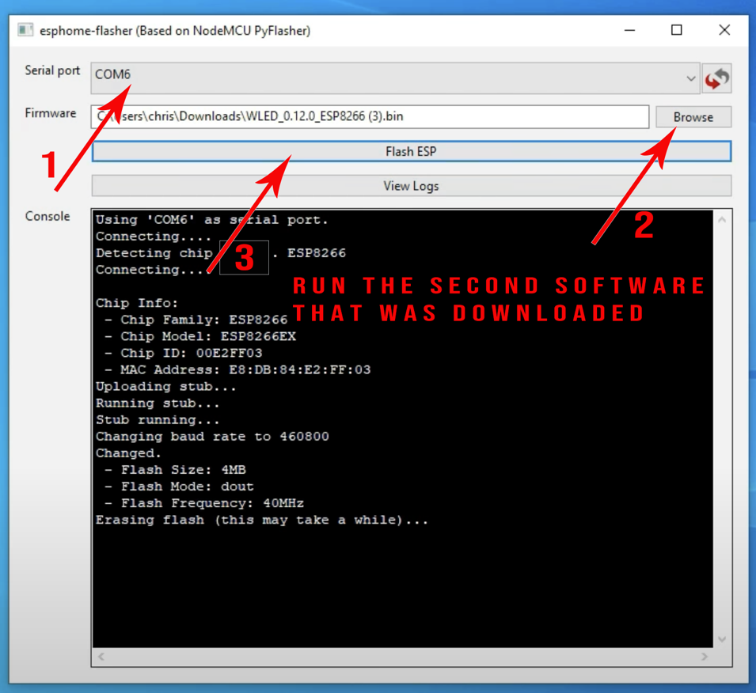

**Step 8** – Connect the ESP8266 to Wi-Fi

* Click on WLED-AP to connect
* Enter Default Password (lowercase): wled1234
* Click Next
* Automatically sends you to the WLED Homepage
* If you’re not transferred to the website, in the URL type in 4.3.2.1

**Step 9** – WLED Home Page

* Click on WIFI SETTINGS
* Enter in the SSID (Network Name)
* Enter Network Password
* Create a name you can remember htttp://looseCannon.local (Example)
* Click Save & Connect
* Close out the website

**Step 10**: Pick up the ESP8266

* Hit the “RST” button on the left of the charging cable. This will save everything you have entered.
* Then, make sure the device is connected to the Wi-Fi

**Step 11** – URL address and WLED Settings

* Type in your URL looseCannon.local (Example)
* Click Config > LED preferences
* Enter in Total LED count:
* Hit Save > Back
* Go to the color wheel and make sure the colors match up
* If colors do not match up go to Config > LED Preferences
* Scroll down to LED outputs:
* Play with the color order to get a color match you desire